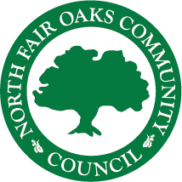

**Working Together for a Better North Fair Oaks**